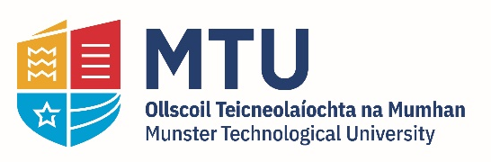
FlowDyn - PhD Scholarships

Sustainable Infrastructure Research & Innovation Group (SIRIG)
School of Building & Civil Engineering
MTU Cork Campus
February, 2024

PhD Scholarships

FlowDyn team needs 6 PhD candidates for an Irish Doctoral Cohort on Offshore Dynamic Cables
University College Dublin with University College Cork and Munster Technological University is leading Ireland’s first national doctoral cohort on offshore dynamic cables.
The lifetime of the PhD is 36 months. The funding provides a EUR25,000 stipend (tax-free) per year and relevant student fees. There are also opportunities for travel and networking nationally and internationally.
The doctoral cohort will work within a large, dynamic, and complementary group of researchers representing leadership in the field of energy and mechanics. The project will be managed by UCD Centre for Mechanics, Dynamical Systems and Risk Laboratory.
We are looking for well-trained candidates in fundamentals – be it theory, numerical methods or experimentation. Successful candidates should have logical clarity, a genuine interest in engaging with the process of doctoral research, clear fundamental training and an appreciation of the works of other (relevant) researchers. The doctoral cohort will be challenging, exciting and a nice place to work in. We expect the candidates to be collaborative, cooperative and a pleasure to work with. The cohort will allow for flexible approaches and training and strive to strike a balance between work and personal life reasonably. We want quality time spent for the project and the candidates in terms of preparedness around the offshore sector robustly and rigorously.
The schematic attached presents the flavour of each PhD. It is not necessary to cover all the topics to apply. However, we do want candidates particularly strong in at least one of the topics listed for the PhD.

If you think you are the right candidate email those listed below (cc-ing Vikram Pakrashi, Vikram.Pakrashi@ucd.ie). Make sure you look up offshore dynamic cables and provide relevant and related information about yourself when you contact. Please include your CV and a letter explaining why you are relevant for the position.

D1: Jennifer Keenahan (Jennifer.Keenahan@ucd.ie) Jennifer Keenahan
D2: Rui Teixeira (Rui.Teixeira@ucd.ie), Rui Teixeira
D3: Vesna Jaksic (Vesna.Jaksic@mtu.ie) Vesna Jaksic
D4: Jimmy Murphy (Jimmy.Murphy@ucc.ie) Jimmy Murphy
D5: Kevin Nolan (Kevin.Nolan@ucd.ie) Kevin Nolan
D6: Philip Cardiff (Philip.Cardiff@ucd.ie) Philip Cardiff
The MTU Sustainable Infrastructure Research & Innovation Group (SIRIG), School of Building & Civil Engineering is pleased to offer a PhD scholarship for research in the area of design, material and structural testing of dynamic cables.

The PhDs will concurrently start from September 2024.

